Entner-Doudoroff Pathway
- Entner–Doudoroff pathway is an alternative metabolic pathway of glycolysis where glucose is converted into Pyruvate with the help of a series of reactions and enzymes.
- Those bacteria are unable to perform glycolysis due to the absence of glycolytic enzymes they perform ED pathway to break down the glucose molecule into pyruvate.
- This pathway was first reported by Entner and Doudoroff (1952) and MacGee and Doudoroff (1954) in the bacterium Pseudomonas saccharophila.
- Recent evidence showed that this pathway also found in cyanobacteria, ferns, algae, mosses, and plants.
- In this pathway, two unique enzymes are involved such as 2-keto-deoxy-6-phosphogluconate (KDPG) aldolase and 6-phosphogluconate dehydratase aldolase.
- In ED pathway 1 ATP is formed per glucose molecule and as well as 1 NADH and 1 NADPH.

Entner–Doudoroff pathway containing Organisms
- Those bacteria unable to metabolism glucose by using glycolysis follow this alternative or ED pathway to break the glucose into pyruvate. For example, Pseudomonas lacks the essential glycolytic enzyme phosphofructokinase, that’s why they follow the ED pathway to form pyruvate from Glucose.
- Only the aerobic and facultative anaerobes use the Entner–Doudoroff pathway and anaerobes use glycolysis due to its low energy yield.
Some example of bacteria those contain Entner–Doudoroff pathway are Pseudomonas, Azotobacter, Rhizobium, Agrobacterium, Escherichia coli, Enterococcus faecalis, Xanthomonas campestris, Zymomonas mobilis, Enterococcus faecalis. This pathway also found in Hordeum vulgare, Phaeodactylum tricornutum.

The Entner-Doudoroff pathway begins with the same reactions as the pentose phosphate pathway, the formation of glucose 6-phosphate and 6-phosphogluconate. Instead of being further oxidized, 6-phosphogluconate is dehydrated to form 2-keto-3-deoxy-6-phosphogluconate or KDPG, the key intermediate in this pathway. KDPG is then cleaved by KDPG aldolase to pyruvate and glyceraldehyde 3-phosphate. The glyceraldehyde 3-phosphate is converted to pyruvate in the bottom portion of the glycolytic pathway. If the Entner-Doudoroff pathway degrades glucose to pyruvate in this way, it yields one ATP, one NADPH, and one NADH per glucose metabolized.
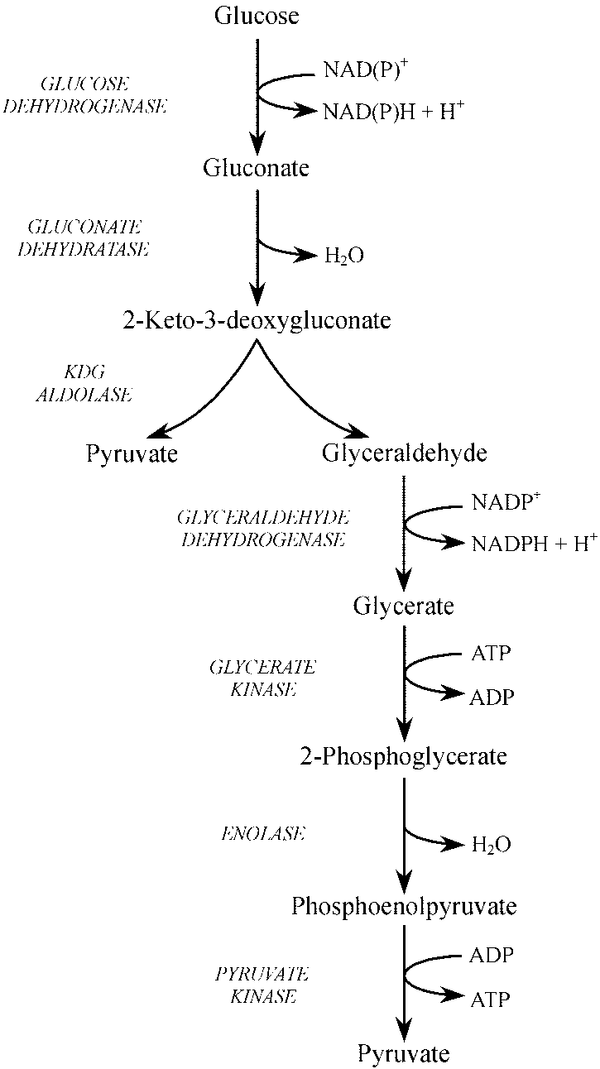
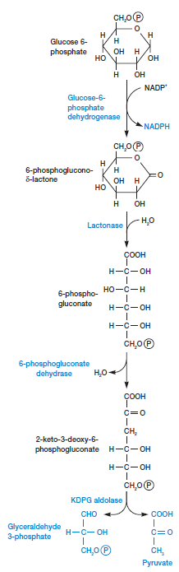
Figure: First-half of ED pathway

